After the Accident
A Step-By-Step Guide

Presented By Rhome Zabriskie
Attorney at Zabriskie Law Firm

Introduction:

Every day, far too many people are seriously injured in car accidents and left with nothing but pain and suffering as a result of something they certainly didn’t expect.
Having represented hundreds of auto injury victims over the years, I have witnessed the terrible stress and anxiety that these victims go through when they are injured in an auto accident due to someone else’s negligence. Not only are they in pain, but they are also stressed out, wondering how they are going to pay their monthly bills or put food on the table. In some cases, their inability to work not only creates devastating effects on their life, but also for their family.
Because of the overwhelming stress and pressures of the accident, they contemplate whether they should “give in” to the insurance company, or deal with the equally challenging process of finding the right lawyer to help settle a claim to their advantage.
This guidebook provides a simple step-by-step process for dealing with each of these complex issues, and many you may not have considered. These steps are placed in an order based upon the issues that seem to be the most pressing following a car crash. I have also included “workbook sections” that allow you to record and maintain information vital to your immediate insurance coverage concerns, which will add value to your future bodily injury claim as well. Remember, although this information will be invaluable, accident victims are not lawyers, and having a legal professional in your corner makes all the difference in the world.
Keep in mind that all information provided here anticipates that your accident happened in the State of Utah.

NOTE: This booklet is primarily written to instruct the Not at Fault Driver; however, much of the information included is useful for any accident victim. At Fault Drivers will find the information regarding medical bill payments and property damage claims very helpful.

Table of Contents:

Index: Ready Reference of Legal and Insurance Terms

Step 1: Maintain Important Information

Step 2: Seeking Medical Treatment

Step 3: Preserving Evidence

Step 4: Replacing Your Vehicle

Step 5: Recovering for other Property Losses and Rental Car

Step 6: Arranging Payment of Medical Bills

Step 7: Receiving Compensation for Wage Losses

Step 8: Collecting Money for Injury and Pain and Suffering

Step 9: Accident Aftermath Journal Writing

Ready Reference Legal and Insurance Terms
After an accident, most people don’t have time to brush up on their legalese, take a class on insurance terminology, or sit though hours of Wiki-searching online— just to figure out what the heck people are saying about their rights under various insurance contracts and state laws.
If you love to read case law journals, long medical reviews or volunteer for root canals for fun… more power to you. But for the rest of the world I’ve compiled a list of helpful terms and insurance acronyms you may need to know moving forward.

●Auto No-Fault— Utah is considered an auto no-fault state. What this means is that regardless of who is liable for the accident, the motorist (and the insurance company on the vehicle he/she is operating) is obliged to provide PIP (personal injury protection) coverage to each and every person in the vehicle he/she is operating. The minimum coverage in Utah is $3,000. A driver can purchase additional coverage if desired.
● Adverse Insurance— The plaintiff’s insurance company.
● Bodily Injury (BI)— Insurance coverage protecting a negligent motorist from lawsuits by those claiming injury against the insured. The minimum coverage allowed in Utah is $25,000 per person and $50,000 total per accident.
● Damages— According to the law, this word does not mean “damage.” Instead, the term is used interchangeably for “claimed losses” and “the sum of money recovered for an injury claim.”
● Essential Services— Insurance coverage permitting an injured individual to pay some person to assist in chores and duties around the house during a period of physical disability brought on by an auto accident. This coverage is available to those in the insured vehicle (it doesn’t matter who is liable).
● Insurance Adjuster— A person employed by the insurer or insured to determine the amount of the loss under an insurance policy.
● Liability— Term used to signify “fault” according to the law.
● Lost Wages— Insurance benefit allowing an injured motorist or his passenger to receive compensation for wages lost as a result of a disability resulting from an auto accident (doesn’t matter who is liable). Typically, this benefit allows the lower of $250 per week or 85% of the wages lost. Most policies will pay nothing unless absence from work is recommended by an MD, or a Chiropractor and work missed is (3) full days or more.
● Negligence— A breach of a legal duty.
● Property Damage Coverage (PD)— This is the coverage carried on an auto insurance policy to cover the damage caused to “other” vehicles, or property as a result of the negligence of the motorist in the insured vehicle.
● PIP— Personal Injury Protection, sometimes called “no-fault” coverage, is an extension of car insurance covering medical expenses and in some cases lost wages and other damages sustained in an auto accident. PIP is designed to be paid regardless of who is at fault. PIP is also called “no-fault” because, by definition, your insurance premium should not increase due to a PIP claim. This coverage is mandatory in Utah. PIP may also include wage loss and compensation for household assistance.
● Primary Coverage— The insurance company held primarily responsible for the injuries claimed. This is always the insurance company of the defendant, unless they are uninsured. If the defendant is uninsured the plaintiff’s UM coverage becomes primary.
● Secondary Coverage— The insurance company secondarily responsible for a bodily injury claim. The plaintiff’s UIM coverage is always secondary to the defendant’s BI coverage.
● Subrogation— When an insurance company provides coverage under the Utah auto no-fault rules (or a health insurance company provides medical benefits) it is entitled to recoup that money from the motorist (or the motorist’s insurance company).
● Under Insured Motorist (UIM) Coverage— Insurance overage protecting a motorist and his passengers in the event that they sustain bodily injury as a result of the negligent driving of another motorist who has insufficient coverage to compensate those sustaining injury.
● Uninsured Motorist (UM)— Insurance coverage protecting a motorist and his passenger in the event that they sustain bodily injury as a result of the negligent driving of another motorist who has no coverage to compensate those sustaining injury.

STEP 1: Maintaining Important Information

Correct data is vital to your insurance claim or personal injury case. Be as accurate as you can in recording the information below:
Date of Car Crash:
Location of Car Crash: _____
Be as specific as you can and include mile markers if you’re on the highway.
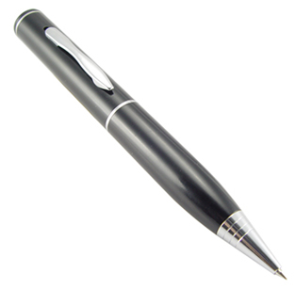
Photos: [Y] [N] [Maybe]
[See Step 3: Preserving Evidence]

Information Regarding The Other Motorist & Their Insurance
- Name of the at-fault motorist, (the other driver involved):

- Name of other motorist’s auto insurance company:

- Phone number of the at-fault motorist’s insurance company’s claims office:

- Claim number with the other motorist’s insurance company

- Name of the insurance adjustor assigned to the bodily injury (BI) portion of your claim:
Name Phone #
- Name of the insurance adjustor assigned to the property damage portion of your claim:
Name Phone #
- Contact info of any witnesses to the accident, including passengers in your own vehicle:
Name Phone #

Name Phone #

Name Phone #

Name Phone #

Name Phone #

LEGAL TIP: From the Desk of Rhome Zabriskie, Attorney at Law
If the other motorist has not reported the collision to their own insurance, you may report the accident. However, you should not attempt to report the claim, or speak to the at-fault motorist’s insurance company without first consulting an attorney. An insurance company has too many ways to trick you into making statements that will diminish your prospect of recovering money.
Bonus Tip: Remember, by law you can have access to the police report from your accident, which may help in answering some of the questions above about the other driver, and their insurance company information. An attorney can, many times, expedite that report, as people tend to pay more attention to such a request when it’s coming from a lawyer.
Information Regarding the Insurance on the Car You Were In
- Name of the Owner of the car:

- Name of the Insurance Company:

- Phone number of the insurance company’s claims office:

- Claim Number with the insurance company:

- Contact info of the Adjustor assigned to the PIP (personal injury protection) portion of the claim:
Name Phone #
- Contact info of the Adjustor assigned to the property damage portion of the claim:
Name Phone #

IMPORTANT TO KNOW: Under the Personal Injury Protection (PIP) of your claim, and specifically the Utah No-Fault Benefits, you may be eligible for compensation to cover medical bills, lost wages, or a temporary house keeper. This comes from the insurance of the car you are traveling in, or if you’re a pedestrian, the car that hit you. These benefits are issued regardless of who’s at fault.
Information Regarding Your Own Personal Health Coverage

“
’’

When we talked with our insurance company, they didn’t really explain the PIP fund very well, so we didn’t know how to benefit from it. I didn’t realize at the time, that we didn’t have to pay for it all ourselves.
~ Raschel H.

- Name of your Health Insurance company:

- Phone number of the insurance company’s claims office:

- Your Policy Number:

Information Regarding Police Activity
- Police department reporting on the car crash:

- Police Incident number assigned:

- Police Officers responding to your accident:
Name

Name

Name
Sometimes an internal delay in filing your police report down at the station can result in a delay in your insurance claim. You are completely justified in contacting the officer to follow up regarding your unfiled report. Here again, is another important moment when having an attorney contact the officer can help the paperwork be filed in a timely manner.

Information Regarding Towing, Storage, and Repair of Vehicle
- Name of the Tow Company removing your vehicle from the scene:

- Telephone Number for the tow company:

- Location where your vehicle has been removed to (i.e., tow yard, collision repair center):

- Name of the Collision Company doing repairs on your vehicle:

- Phone Number for the collision company doing repairs on your vehicle:

- Address for the collision company doing repairs on your vehicle:

Information Regarding Medical Care [NOTE: Leave blank if not applicable]
- Contact info of Ambulance Service attending to you, at the scene of the accident:
Name Phone #
- Contact info of Hospital you were transported to:
Name Phone #
- Contact info of Family Doctor you have seen:
Name Phone #
- Contact info of Physical Therapist you have seen:
Name Phone #
- Contact info of Chiropractor you have seen:
Name Phone #
- Contact info of any Surgeon you have seen:
Name Phone #
- Contact info of any Radiology Center you have been:
Name Phone #

STEP 2: Seeking Medical Treatment

Disclaimer:
Nothing stated herein should be interpreted as medical advice. Any decision to receive medical care or not, should be made with the advice of qualified medical professionals.
When Should I See A Doctor?
If you feel any pain or discomfort since your accident, or if you are concerned that you may have suffered injury, you should seek medical attention immediately. Sometimes, after an accident, you may not actually feel any immediate pain, but there could still be internal damage that surfaces later on, so getting checked out immediately is recommended. The longer you delay treatment, the longer it will take to recover your health.
Delaying treatment can also decrease the value of your potential injury claim. Insurance lawyers love it when people delay their treatment, because it provides them with the opportunity to blame the injured party for any claimed long-term pain and suffering. Delaying medical treatment also helps insurance lawyers by giving them the opportunity to argue that the injury must have been caused by something that happened “after the car crash.” Tactics like throwing the blame back to you are all too common for the insurance company, as they try to avoid payment. Giving the insurance company this kind of argument will not help your claim at all.
What Type Of Medical Care Can I Seek?
Doctors and/or Chiropractors can start and direct your medical care almost immediately. Either one will be covered under the PIP (Personal Injury Protection) coverage of the car you were in at the time of the crash.
You should take the advice of trained medical professionals regarding which course of care to take, based on your injuries. Do not ignore, or treat lightly their expert recommendations, because doing so may hurt your case.
How Long Should I Be Treated For My Injuries?
This decision will be made by a qualified doctor, almost 100% of the time. If you miss any medical appointments, or just decide to stop treatments on your own, you can decrease the value of your potential injury claim; however, over-treating your injuries can have the same negative impact on your case. Because doctors are considered, “subject matter experts”, their opinions can play a big role when it comes to courts and rulings. So until instructed to do so, do not stop any medications prescribed, conditioning, strength training or at-home exercise your medical provider suggests.
You can really help yourself by being honest and up-front with the doctors treating your condition, and about what treatments seem to be working, or not working.

STEP 3: Preserving Evidence

Whether accidents ultimately involve a trial or not, evidence from the scene will influence the value of your case. Insurance adjusters, police, attorneys and others need to see the entire picture from every possible side. Key evidence collected will help them determine how to best handle your case. The more you can help in this process, the better off you may be. Remember, everyone is working for someone, so being detailed and documenting everything is a smart thing to do.
At-Fault Driver Conviction
This is a part of the “evidence preservation” process that you might not think of right away; however, holding the at-fault motorist responsible to the fullest extent of the law will, in some cases, strengthen your standing as you move forward with any other claims.
LEGAL TIP:
You should consult with an attorney to see if it is advisable that you make sure the at-fault motorist received a guilty conviction for any moving violation that may have contributed to your accident.
Vehicle Preservation
If you have been injured in a car accident, preservation of evidence is critical. In some cases, it’s important and even necessary, that the entire vehicle be preserved in its damaged state. You need to consult an attorney regarding these issues.
Accident Photographs
Obtaining photos of the scene, and your vehicle, is an important step in documenting your accident, and a good way to improve your case. If you took pictures at the time of the accident, you need to develop, or download them as soon as possible. Make them available to your insurance company and any adjustors; however, it’s best to run them by an attorney first.
Take photographs of all visible damage to your vehicle before any repairs are done. If you are unable to get the photos at the time of your accident, find out where your vehicle is being stored, and make an appointment to take pictures of your vehicle. If the other vehicle is at the same location, try to take a few pictures of it also.
Under no circumstances should you try to enter private property without permission, like a junk yard or salvage yard to take pictures. If you can see your vehicle from a public sidewalk, you may take pictures by zooming in. Contacting the yard or collision repair facility and obtain permission before entering.
We realize that in an accident, sometimes you may not be in a position to take the necessary pictures, nor have the proper state of mind to do so; however, below is an ideal example of photos that may help:
[Check off the ones you have already taken.]
  - Full frame of your vehicle, from bumper to bumper
My smashed car
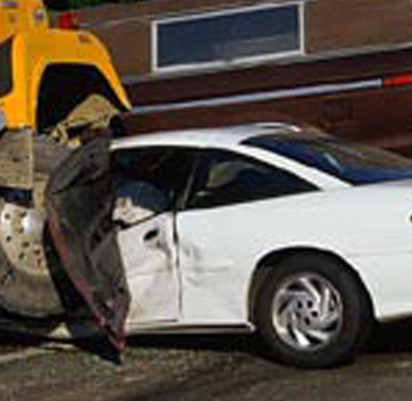
  - Detailed photos of your vehicle’s damaged areas with close-ups if possible
  - Establishing photos of the general accident scene, which may include wide shots of the intersection, or main streets and traffic flow
  - A driver’s view photo from inside the car looking through the windshield… if unobstructed
  - Full frame of the other vehicle(s) involved
  - Detailed photos of the other vehicle(s) damage with close ups as needed
  - Any relevant obstacles or structures pertaining to the accident, such as fences, curbs, telephone poles, street signs. (any damage to anything caused by the accident)
If you do NOT have any of the photos, write down in as much detail as you can remember, describing the scene as outlined above. If possible, return to the scene of your accident and take pictures of the surrounding streets, obstructions or anything that may be relevant to your case. Above all, be safe and don’t try to get any pictures from an unsafe area.
[Record Your Photos in the Appendix Section Provided]

STEP 4: Replacing Your Vehicle
Who Pays for My Vehicle?
If the accident wasn’t your fault, then compensation for your damaged vehicle will be paid by the insurance of the at-fault driver. Alternatively, you can receive compensation from your own auto insurance as well. When using your own insurance, you must have comprehensive coverage, and you must be willing to pay your deductible.
LEGAL TIP:
Your deductible may be recouped from the at-fault driver’s insurance, but the
Process can be long, and you may have to call to follow up numerous times.
Getting an attorney involved is one way to make the insurance company wake up and take notice.
General Provisions
The whole point of insurance is to restore you to the condition you were in before your accident. So, you have several options when it comes to compensation for the damage to your vehicle. Insurance must “Restore” you in one of three ways: Repair, Payment or Replacement.
1) Repairs—Repairs for your vehicle can be paid for directly by the insurance company. You must be very careful when selecting a repair shop to handle your vehicle, as all insurance companies have preferences regarding how, when and with whom these repairs take place. Ultimately the choice of a repair shop belongs to you.
LEGAL TIP:
Some insurance companies will try to do replacements using cheaper components. For instance, if your side mirror gets shattered, and you need a replacement… some insurance companies will try to put a low-end reflective plate or lower grade of glass than the original factory-issued mirror.
Getting an attorney involved will make sure you get the max repair value you deserve.

2) Payment—You may also choose the option of
receiving money equal to the amount of
your vehicle repair estimates.
However, if your vehicle is
totaled, meaning; the repairs
would cost more than the value
of the vehicle prior to your
accident, you may forfeit the
vehicle and receive
compensation for
the lost vehicle, or you may keep
the vehicle and receive reduced
compensation for the total loss.

LEGAL TIP:
Remember the “total loss” values are negotiable. Make sure you speak to a qualified attorney before accepting any amount as settlement for damage to your vehicle. You should also consult an attorney before signing any release documents so you don’t release your right to later add other property damage and bodily injury claims.

3) Replacement—For vehicles, the ultimate replacement will become your choice, if you choose to take the cash and shop for another car. This is another reason for getting an attorney to make sure you get every penny allowed under the law, so you can buy something you like… not just four wheels with a motor.
Another form of temporary replacement is a rental car, while you await the outcome of your claim. This will be covered more in the next step.
STEP 5: Recovering for Other Property Losses and Rental Car

Who Pays for a Rental Car?
If you were not “at-fault”, you can get a rental car paid for during the same period of time by the insurance covering the at-fault driver, or by your own insurance, if you have rental car coverage on your policy.
General Provisions
You could be entitled to receive compensation for days which you could have used a rental car, but one was not provided to you. Knowing exactly what you’re entitled to for the lost use of your vehicle may be a little hard to sort out, but well worth it. If you were not at-fault for the collision and you are seeking rental car coverage from the other driver’s insurance company, you will probably need to provide a copy of the police report before rental car compensation will be provided to you. You may also be required to offer a statement of the facts.
LEGAL TIP:
Offering a statement, without the advice of a lawyer, could jeopardize your prospects for receiving compensation for bodily injury. Such a statement could be used in court, and must be carefully worded to ensure that the facts are not twisted to fit how the insurance company wants you to appear.

Property Losses Other Than Your Vehicle
If you had personal items damaged in the crash, like things inside your car, in your trunk, or anything being towed behind your vehicle, you may be entitled to payment under the same conditions as outlined for the rental car compensation above; You can be compensated by the at fault person’s insurance company, or by your own insurance company, if you have comprehensive coverage.

STEP 6: Arranging Payment of Medical Bills

Who pays my medical bills?
The coverage that deals with this part of the accident is the Personal Injury Protection (PIP) Medical Coverage:
After being injured from a car crash in Utah, you are first entitled to medical benefits coverage under the insurance on the car you were in. The minimum coverage on any Utah policy is $3,000, but depending upon the policy it can be as high as $100,000 per injured person. The coverage amount will be identified on the policy Declaration Page, of your insurance policy. If you don’t have your policy readily available, just call your agent and they can look it up.
How Do I Qualify For PIP Medical Coverage?
To find out if you will qualify for this coverage, you just need to contact the insurance company covering the car you were in, and request an “Application for Benefits.” Once the application has been completed, signed and submitted you will need to provide the billing department, (for each of your medical providers,) with the claim number and contact information for the insurance company providing you with PIP coverage. Make sure you have an attorney look over the application before you “submit” it.
Once the maximum coverage has been paid out, you will receive a “PIP Exhaustion letter” from the auto insurance company. I know that process can sound tiring, but doing things correctly will be well worth it.
LEGAL TIP:
You should not complete the Application for Benefits form without consulting an attorney. There are too many things that you could say, or withhold, which could damage your potential for recovering money for your injury. As a rule of thumb, don’t fill out any official documentation without first consulting with your attorney.

Who Pays Next?
The next insurance coverage in the line-up, after your PIP coverage, is your own personal health insurance. You should provide your policy number and contact information to each health care provider who has not been paid by your PIP coverage. All outstanding medical bills should be covered in accordance with the terms of your own health insurance policy. Make sure you read and have a decent knowledge of what your policy includes. Remember that definitions can all be looked up online. (Wikipedia.com or Dictionary.com)
LEGAL TIP:
Based on the Doctrine of Adhesion, if the insurance contract is in any way vague or unclear, any ambiguity will be construed in favor of the insured, since you had no chance to change it when you bought coverage. Adhesion, references to you having to “Stick” or Adhere to the language in the contract with no opportunity to negotiate it. An attorney can determine if such language is vague in your policy.

Who Pays After My Health Insurance?
If you don’t have health insurance, or if your health insurance only pays a portion of your bills, you can arrange to pay the outstanding bills yourself, or speak to an attorney about putting a lien in place to suspend any collection action on your account. This could be very important to your current and financial future, so be sure to speak with an attorney to answer the tough questions that might come up during this time.
STEP 7: Receiving Compensation for Wage Losses
Although your claim for lost wages may ultimately be directed against the at-fault driver and/or the auto insurance for that driver, Utah law still allows you to collect limited lost wages under the policy of the car you were in, at the time of the crash (or the car that hit you, if you were a pedestrian). The standard coverage allows you to be compensated at a rate of 85% of your actual wage loss, or $250 per week, whichever is lower.
In order to qualify for lost-wage compensation from the insurance of the car you were in, you must qualify in ALL of the following ways:
1. Have a medical release from a medical doctor or a Chiropractor.
2. Miss at least 3 consecutive days of work.
3. Provide a completed wage verification form. This form comes with the standard “Application-for-Benefits” provided by the insurance company on the car you were in (or on the car you were struck by, if you were a pedestrian). Any Wages recovered, under the policy provision described above, and additional lost wages, will be sought by your attorney in any final demand for settlement of your bodily injury claim.
STEP 8: Collecting Money for Injury and Pain and Suffering
How much you can collect for any injury is limited by three main factors:
1. The amount of money available through insurance companies
2. The severity of your injuries
3. Other financial losses resulting from you being injured
Sometimes, the monetary value of your injury(ies) exceeds the amount of money that is available from the insurance company. However, in the majority of cases, there is enough money available to provide fair compensation for your injuries. The challenge is getting the person, or insurance company controlling that money, to give you enough to provide fair compensation. This is another area, where having the right lawyer is critical.

LEGAL TIP:
A lawyer can determine when the time is appropriate to make a demand for settlement. They can also discover all the different sources of money that are available to you, including sources of recovery, above and beyond the amount of money available under the at-fault motorists bodily injury limits. An experienced lawyer can help to identify umbrella coverage, under-insured motorist coverage, and uninsured motorist coverage. Surprisingly, sometimes coverage can be tapped into on policies for cars that were not even involved in the collision.

Finally, in many instances, an attorney can aid in protecting the money you will recover from insurance companies and other parties of interest who may want to assert a claim against your settlement proceeds. Or in other words, creditors or other people who want to get at the money you received from your accident or injuries.
The proven fact is car crash victims collect more money for their injuries, on average, than victims who attempt to settle an injury claim on their own. Before you discuss any settlement options with an insurance agent, you should consult with an experienced personal injury attorney.

STEP 9: Pain and Inconvenience Journal Writing
Accident Aftermath Journal
After going through a frustrating and probably painful accident experience, time will pass. The accident investigation, adjustor analysis and any legal proceedings may take a while to move through the system. During this time, details and memories tend to fade. Although you have most likely already filled out a police report and something for the insurance company, we strongly recommend keeping an Accident Aftermath Journal.
Simply put, this journal should contain all of the details about the accident itself, but also your reflections following the accident.
LEGAL TIP:
An Accident Aftermath Journal is a good way to document your personal thoughts and feelings following a traumatic crash. Sometimes this type of first-person perspective can be valuable in a personal injury case because it shows a progression of thoughts and records relative amounts of pain and suffering after the accident. An attorney would help you know if your writings should be used.

If you are injured you should consider recording relevant changes you experience; such as the following:
● Levels of pain (1-10) from day to day or week to week—be specific about areas of pain, type of pain by using good descriptive words. (Dull, sharp, throbbing etc…)
● Tasks at work that are now difficult or take more work to accomplish
● Other activities that are hard to do following the accident—list the mundane, such as folding laundry as well as things like playing sports, and anything that is now uncomfortable
● Include any improvements, or worsening in your physical condition
● Write about your medical care and ongoing treatment or therapy
● Fears and concerns about the future
● Thoughts of frustration, sadness, or depression
NOTE: If your feelings of sadness or depression last longer than normal, consult an experienced medical professional to discuss your situation

Disclaimer:
The above suggestions are meant only to show examples of subject matter for your journal. Only write about what applies directly to you and your specific accident. Remember do not exaggerate, be dishonest or misleading about your statements in your journal, as it may become part of your open claim.
An Accident Aftermath Journal is not only a good way to document your experience, but it may also provide relief on an emotional level by writing your thoughts, feelings, impressions and reactions. Several blank pages are available in the Appendix for you to start your Journal. Use additional sheets as needed.
[See Appendix: Journal]

NEXT STEPS: When to Get Legal Help

“
’’

Zabriskie Law Firm helped me really understand what “representing” us means, at the highest level. Once we started working together, I didn’t have to talk to the insurance again; they helped us understand the system and took control to make us feel at ease and much less stressed. ~ Keaka

Selecting an Attorney
When you need legal representation, whether it’s to fight a large insurance company, to help hasten police procedures, or to push paperwork through quickly… you need an expert in your corner. Make sure you hire an attorney with experience and someone with whom you can communicate and work well. We hope this guide has been helpful, informative and a good starting place, should you need further legal assistance,

ACTION ITEM:
If you would like to speak to an attorney about your accident, consider the Zabriskie Law Firm. We offer a free consultation and would be happy to answer any questions you may have after reviewing the material contained in this Guide. We are available 24/7 to speak with you about your case, and we have (3) office locations to serve you.
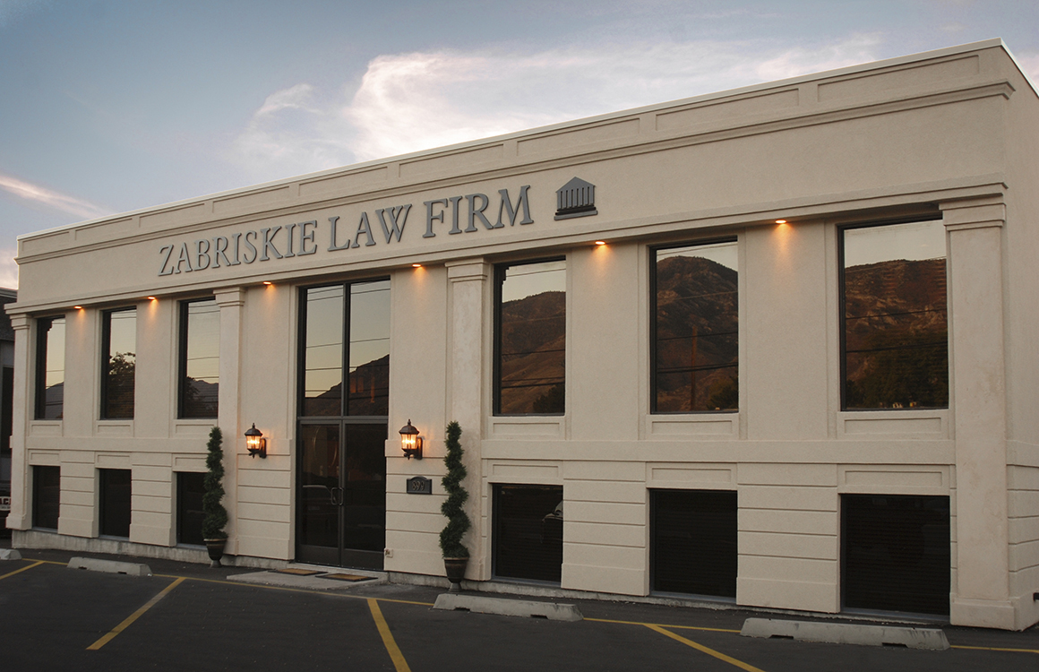

Zabriskie Law is Ready to Help: 800.608.9161

Provo Office:
899 North Freedom Blvd.
Suite # 200
Provo, Utah 84604

888.922.7475

Salt Lake City:
4360 South Redwood Rd.
Suite #1
Salt Lake City, Utah 84123
Down Town Salt Lake:
299 South Main St., Floor 13
Wells Fargo Building
Salt Lake City, Utah 84111

